Procurement Processes and Guidelines
Table of contents
1. Purpose……………………………………………………………………………………………. 2
2. Compliance in Using Registered Suppliers…………………………… …………... 2
3. Procedure To Be Followed……………………………………………………………….. 2
4. Procurement Thresholds.……………………………………………………............... 2
4.1 Category 1..………………………………………………………..……………… 2
4.2 Category 2………………………………………………………………………….. 3
4.3 Category 3………………………………………………………………………….. 3
4.4 Category 4………………………………………………………………………….. 4
4.5 Category 5……….…………………………………………………………………….. 5
5. Composition of the Specification and Evaluation Committees………….. 5
5.1 Bid Specification Committee…………………………………………….. 5
5.2 Bid Evaluation Committee………………………………………………… 6
5.3 Making Recommendations for bids <R500 000…………………. 7
5.4 Making Recommendations for bids >R500 000…………………. 8
5.5 Acceptance of Recommendations …………………………………… 8
6. Request for Order……………………………………………………………………………. 8
7. Generation of Purchase Order………………………………………………………… 8
8. Payment of Suppliers……………………………………………………………………….. 9
9. Contracts…………………………………………………………………………….. ………….. 9 & 10
10. Summary of Process Flow………………………………………………………………. 10
- Purpose:
To give guidance and detailed step by step process on the procurement of goods and services in line with the thresholds as prescribed by the Public Finance Management Act (PFMA), a framework that guides uniformity in the procurement processes of government departments and entities. The Government’s aim for issuing procurement guidelines is to prescribe a standard of behaviour, ethics and accountability required of its public service and also as a statement of the Government’s commitment to a procurement system which enables the emergence of sustainable small, medium and micro businesses which will add to the common wealth of the country and the achievement of enhanced economic and social well-being of all South Africans.
The aim of the Procurement Processes and Guidelines is to enforce proper and successful government procurement that rests upon the five pillars of procurement as listed in the constitution. They serve to ensure that procurement of goods and services is done in a manner that promotes the following:
- Value for money
- Open and Effective Competition
- Ethics and Fair Dealing
- Accountability and Reporting
- Equity

- Compliance with respect to using registered suppliers
The end-user (requester) should utilise suppliers registered on SAEON’s Supplier Database or NRF Supplier Database. In case the chosen supplier is not registered, the end-user should request the supplier to register on SAEON’s Supplier Database before they can be used. Registration forms are available on the SAEON Website or request from SAEON National Office.
For procurement requests that require bidding process, bids can be solicited from a list of best suppliers, internet search, use of specialised databases, use of specialised product databases, etc.
- Using the Workflow System - Procedure to be followed:
SAEON will utilise the NRF Workflow System to initiate the procurement process (e-procurement). Only registered users will be able to complete request for orders on the system and the approval will be done electronically by the authorised staff member. The work will be routed to all levels of authority on a step by step process.
The Workflow System requires that all procurement requests be included in a pre-loaded Procurement Plan on the system. When a request is initiated, the system will pull out the request from the procurement plan and identify registered suppliers to send request for quotes to. In cases where the request is not in the Procurement Plan and is less than R100 000, an approval will be required from the Managing Director, above which approval will be requested by the CEO.
Managers are expected to submit their procurement needs with their business plans in January every year.
SAEON National Office and Nodes should be aware of the thresholds in respect of procurement requirements as stipulated in the NRF Supply Chain Management Policy and in line with the PFMA.
To promote uniformity in procurement processes, on receipt of request for purchase order, the Budgets & Procurement Controller will check the request for:
- completeness; budget availability, correct allocation and quotations attached
- compliance with legislative framework in terms of the PFMA

- Procurement Category Requirements - Thresholds
4.1 Category 1: Purchases between R1 < R2,000 (including all taxes)
a) If petty cash is used the request is accompanied by at least 1 written quotation/receipt/invoice. Petty cash limit of R500 per transaction placed on the nodes and R1 000 for the National Office should be observed accordingly
b) If procurement request needs a purchase order and payment will be effected by Electronic Funds Transfer (EFT), request should be accompanied by at least 1 written quotation and a record of two other telephonic or verbal quotations recorded on a quotes form.
c) Request for accommodation should be accompanied by at least 3 quotations of which one is written quotation and the other two can be telephonic with traceable record and should be paid via EFT. Rates placed on establishments’ websites are not frequently updated so cannot be relied upon. Telephonic confirmation should be made and recorded.
d) Requests for purchase of assets (e.g. office chairs, printers, etc., should not be paid for through petty cash or S & T claims. A request for Order accompanied by Capex acquisition form (approved by Managing Director) and three written quotations should be sent to National Office for purchase order generation.
e) In a situation where 3 written quotations cannot be obtained or the lowest quotation cannot be accepted due to circumstances beyond control, the end-user has the onus to give reasons in writing to request approval to diverge from normal policy prescripts.
f) Petty cash credit cards can also be used to pay for purchases <R2 000 per transaction. Petty cash rules apply with regards to receipts and non-purchase of assets
g) Where petty cash or petty cash credit card is used to acquire goods/services, reconciliations should be done before the monthly limit is exhausted
4.2 Category 2: Purchases from R2,000 to R10,000 (including all taxes)
a) Request for purchase order should be accompanied by at least 3 or more written quotations obtained from suppliers who are registered on SAEON's Supplier Database.

NB: the lowest quote will be favoured if it meets minimum requirements
b) In case the supplier of preference is not registered in SAEON's Supplier Database, the necessary steps should be taken to register that supplier in SAEON's Database before an order can be placed with the supplier.
c) New Suppliers registration forms should be accompanied by EFT bank account confirmation form stamped by bank or cancelled cheque

4.3 Category 3: Purchases from R10,001 to R30,000 (including all taxes)
a) Request for purchase order should be accompanied by at least three or more written competitive quotations obtained from suppliers registered on SAEON's supplier database.
b) For individual transactions less than R30,000; tax clearance certificate may be submitted if supplier choses to do so but it is not a requirement.
c) A schedule of requirements or specifications must accompany request for purchase order.
The evaluation criteria should be stated on the specifications document
d) The quote with lowest price will be preferred if it meets the requirements. If it is not chosen or if it is not possible to obtain at least three written price quotations, a written motivation stating the reasons should be submitted for approval by the Managing Director.
e) In case the good/service can be sourced from a single source, a motivation should be approved by the Managing Director with irrefutable proof that the goods/service cannot be sourced elsewhere. The single source supplier should submit letter confirming sole supplier status.

4.4 Category 4: Purchases from R30,001 to R500,000 (including all taxes)
a) Request should be open to competitive sourcing of quotations by inviting as many service providers as are registered on the list of prospective suppliers with a minimum of three written quotations.
b) Where no suitable suppliers are available from the list of prospective suppliers, written price quotations may be obtained from other possible suppliers. If the preferred suppliers are not registered in SAEON’s supplier database, the end user has the responsibility to ensure that such a supplier is registered before they can be used.
c) Detailed specifications as agreed upon by all relevant users should accompany purchase request. The same specifications should be sent to all suppliers that are approached for quotes.
d) The evaluation criteria and method to be used should be included and terms of reference articulated in the documents sent to bidders.
e) Responses from suppliers should include Tax Clearance Certificate as a requirement and completed Standard Bidding Documents (SBD) obtainable from National Treasury Website.
f) Committees of at least three people each should be set up for: specifications, evaluation and awarding of bids. The Managing Director is responsible for appointing the specification and evaluation committees as per delegation of authority ( see bullet 5 for composition of committees)
4.5 Category 5: Purchases from R500,001 to R2,000,000 (including all taxes)
a) A competitive bidding process should be followed for purchasing requests in this category by advertising for a minimum of 21 days on the Government Tender Bulletin and other appropriate media to ensure greater exposure to potential bibbers.
b) The bid invitation should be accompanied by detailed specifications, service level criteria and method of evaluation informing bidders what they need to provide in terms of legislative compliance.
c) Tax Clearance Certificate should accompany responses.
d) Bids must be submitted on Standard Bidding documents as published by National Treasury. SBD’s to be completed include: SBD,1,2,3,4,6,7,8,9 and submission of General Conditions of Contract.
e) Evidence of the invitation for bids should be in the Government Bid Bulletin and NRF Website and, where applicable, special media which enables sufficient invitations from prospective bidders should be retained.
f) Mandatory formal committees for specification, evaluation and awarding are necessary. The specification committee should consist of at least three members. Members sitting in the evaluation committee can be comprised of those in the specification committee but should be more than 50% of the evaluation committee
g) Minutes from all committee meetings should be retained together with signed declaration of interest forms.
h) Evaluated bids will be sent to NRF Corporate for award by the Bid Adjudication Committee (BAC). The submission should be accompanied by a detailed checklist on a template provided by NRF Corporate SCM office

- Composition of Specification and Evaluation Committees

  - Bid Specification Committee (BSC)

    - The specification committee must consist of at least three (3) members:
- including the manager responsible for the function involved or the project leader
- a supply chain management practitioner of the institution
- if deemed appropriate, it may include external specialist advisor(s)
The appointment of the specification committee members must be communicated in writing by the accounting office (The Managing Director) specifying the members roles and responsibilities as well as the period of the appointment.
    - Roles and Responsibilities of Specification Committee
A bid specification committee must compile the specification for each competitive bid invited by SAEON for procurement of goods and services. Specifications:
- must be drafted in an unbiased manner to allow all potential providers to offer their goods/services;
- must take into account any accepted standards such as those issued by the Standards South Africa, the International Standards Organisation (ISO) or an authority accredited or recognised by South African National Accreditation System (SANAS) with which the equipment , material or workmanship should comply;
- where possible, be described in terms of performance required rather than in terms of descriptive characteristics for design;
- may not create trade barriers in contract requirements in the form of specifications, plans, drawings, designs, testing and test methods, packaging and marking or labelling of conformity certification;
- may not make any particular reference to trade mark, name, patent, design, type, specific origin or producer unless there is no other sufficiently precise or intelligible way of describing the characteristics of the work, in which case such reference must be accompanied by the words “equivalent’ and
- must indicate each specific goal for which points may be awarded in terms of the points set out in the supply chain management system of the NRF

    - The bid specification committee must also-
- Compile bid documents
- Request proposals (if applicable)
- Draw up terms of reference
- Draw up evaluation criteria; and
- Include special conditions (if applicable)

    - Specifications together with all documents cited in 5.1.3 must be approved by the Bid Adjudication Committee prior to publication of the invitation for bid

  - Bid Evaluation Committee (BEC)

    - The evaluation committee must consist of at least three (3) members:
- one can be taken from the specification committee and the other two must be new members with experience in evaluation of bids
- if more than one were part of the specification committee, they must not compose of more than 50% of the evaluation committee
- the chairperson being a senior employee who has experience in the evaluation of bids

    - Roles and Responsibilities of the Evaluation Committee
The bid evaluation committee must evaluate each competitive bid according to the criteria
stipulated in the bid documentation, the point system as set out in the NRF SCM system and as prescribed in terms of the PPPFA by –
- verifying supplier details
- taking cognisance of the bidders’ declarations of interests
- scrutinizing bids for completeness and technical correctness
- verifying claims in terms of preference points and status
- compliance with conditions of the bid (legitimacy tests)
- compliance with specifications
- consideration of latent and other factors that might have an influence on the award of the bid
- comparison of prices and allocation of preference points for the price and socio-economic objectives
- awarding points in terms of the evaluation criteria and preference claims
- calculating points awarded; and
- evaluate each bidder’s ability to execute the contract

    - The evaluation committee must submit to the bid adjudication committee a report and recommendation with regard to the awarding of the bid or any other related matter, and re-evaluation of bids in cases where bid recommendations have been referred back to the bid evaluation committee by the bid adjudication committee

    - The committee may, before bids are considered for acceptance or before a formal contract is concluded , examine and take into account the following although not limited thereto;
- the financial standing of bidders
- the bidder’ good standing with the South African Revenue Services
- bidder’s financial capability to deal with possible legal action from the institution in respect of non-compliance with specific bid if so being awarded to them;
- bidder’s ability to manufacture, and/or supply goods or render a service
- bidder’s capacity to deliver on the contract taking into account current workload and resources; and
- that all bids duly lodged were taken into consideration by the committee

  - Making Recommendation for bids under R500 000
The evaluating committee makes a recommendation to the Managing Director on which bid(s) should be accepted
  - Making Recommendation for bids above R500 000
The bid evaluation committee evaluates the bids and makes a recommendation to the Bid Adjudication Committee on which bid(s) should be accepted
  - Acceptance of Recommendation

The authoriser/BAC reviews the bid recommendation and accepts the recommendation. If the authoriser/BAC does not agree with the recommendation:
- for bids under R500 000, the evaluation committee is requested to reconsider inputs from the authoriser and make new recommendation. If still in disagreement, the final decision is the authoriser’s and full written details are provided to support the final decision.

- for bids above R500 000, the BEC is requested to consider the inputs from the BAC and make a new recommendation. If still in disagreement, the final decision is that of the BAC as minuted. The SCM office notifies the Auditor General and National Treasury within seven (7) working days in writing of the reason for deviating from such recommendation.

- Requests for Orders

An employee of SAEON may not spend or commit funds of SAEON except with proper approval from the delegated or authorised manager, failing which, the expenditure becomes unauthorised and irregular in which case the transgressor will be forced to pay out of his/her pocket or refund the NRF. The cost centre manager or delegated person must thoroughly check the Request for Order and ensure it contains all the necessary detail used to request quotation before approving the expense requisition under their budget .

Once a need for procuring goods or services has been identified and procurement granted, the initiator should draft specification that will be sent to suppliers to request for quotations. The details sent to the suppliers for requesting quotations should be uniform.
After receiving quotations, the initiator should send completed request for order with details of the goods or services required as per specification and the quoted price to National Office where the Budgets and Procurement Controller will verify budget availability before purchase order is generated.

- Generation of Purchase Order

After the process stated on bullet 5 above has been followed, the Admin Officer Finance and Procurement will generate a purchase order and email/fax it to the supplier and CC the requester.

NB: The supplier must be registered on SAEON’s Supplier Database before an order can be generated. If not, the initiator has to take the necessary steps to do so. The completed registration forms should be accompanied by EFT Form confirming supplier’s bank details stamped by the bank, alternatively a cancelled cheque be submitted with EFT form if not bank stamped.

Purchase orders should precede the actual acquisition of goods and services. No purchase orders will be generated after the goods have been procured from the supplier.

- Payment of Suppliers
- Signing of invoices
Payments to suppliers will be effected once a signed invoice, by the delegated authority (manager) according to financial delegation thresholds, has been received.
NB: Signing of the invoice is acknowledgement that the goods/services have been received in good order and payment should be effected.
Unless prior approval for prepayments has been granted by the Operations Manager, payments to suppliers for goods and services will be effected within 30 days from receipt of supplier’s invoice in full compliance with PFMA. The invoice must be signed by relevant authority (cost centre manager) as acknowledgement that goods and services have been received in good order.

- Payments in Advance
Where payment in advance is required, a pro-forma invoice should be obtained and the necessary motivation for approval should be submitted to the Operations Manager or delegated person.

- Documents Required for Payments
- Request for Order
- At least three (3) quotations (see sections on threshold categories)
- Purchase Order
- Signed Invoice

- Contracts

Where a service is required for a prolonged period and there are terms and conditions of service agreed upon by both parties; i.e., SAEON and Service Provider, a written contract or agreement detailing the agreed rate, commencement and expiry dates should be negotiated by initiator and approved by the Managing Director of SAEON on his capacity as the delegated authority. SAEON does not encourage verbal contracts as there is no record of approval by Managing Director and may result in dispute and misinterpretation of terms and conditions when payment has to be made. Initiators must inform prospective contractors that the contract is provisional and will only be valid upon approval by higher authority.

- Process Flow
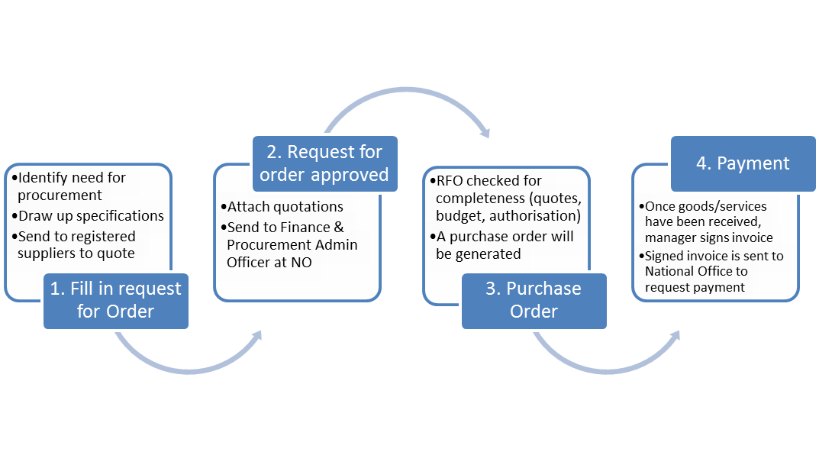
NB. The above guidelines are not amendments to the Supply Chain Management Policy documented by the NRF, but are steps to achieve the goals and objectives of the aforesaid Policy requirements.
Document Name | Document Reference | Date Issued
Procurement Processes & Guidelines | SAEON-PROC-PG.0.1 | 08/05/2013

Initiator | Supported By: | Approved By:
Cindy Hlanze | Amani Saidi | Johan Pauw

